DAY 16

OBJECT-ORIENTED PROGRAMMING

from turtle import Turtle, Screen  
timmy = Turtle() # highlighted is the object  
print(timmy)

my_screen = Screen()  
print(my_screen.canvwidth)

EXPLANATION:

turtle – python module

Turtle – class inside the turtle module

timmy is the object that holds or the class Turtle is assigned to timmy.

Screen - class inside the turtle module.

my_screen is an object holding the class Screen.

my_screen.canvwidth is a method because a function canvwidth is tied with object my_screen.

TO INSTALL PYTHON PACKAGES FROM THE **PYTHON PACKAGE INDEX:**

File -> settings -> your project -> python interpreter -> (+) option -> In the search type the name of the package and click install package.

To see the package, type import package_name in the coding window, hover over the package_name, right-click, and select the go-to option, then implementation to see how the package has been written.

EXAMPLE:

from prettytable import PrettyTable  
table = PrettyTable()  
  
table.add_column("Pokemon name",["Pikachu", "Squirtle", "Charmander"])  
table.add_column("type",["electric", "water", "free"])  
print(table)

the above example is to table format the data using a prettytable package.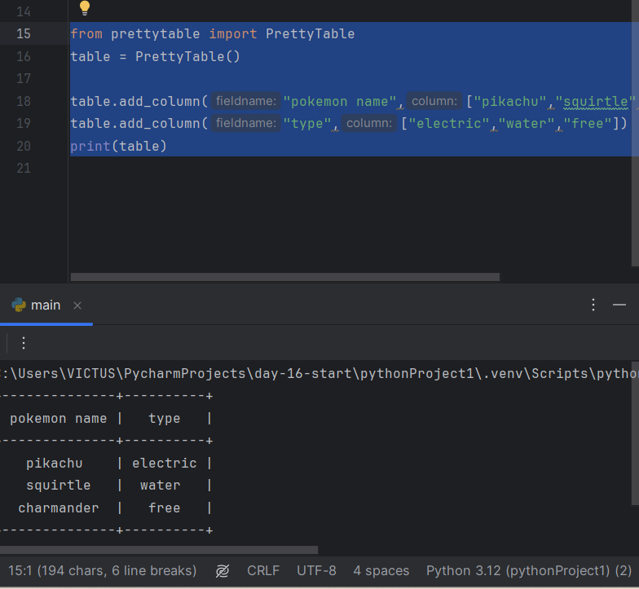

heap is where all objects live